Introduction to the Humanities
CRN 11131 HUM1020
MW: 2:30-3:45
Room: 5 -111
Professor Bob G. Warren

Please read this syllabus for general classroom rules as well as an idea of the intent of the class generally. For a more specific day to day assignment list and instructions: Attend Class.

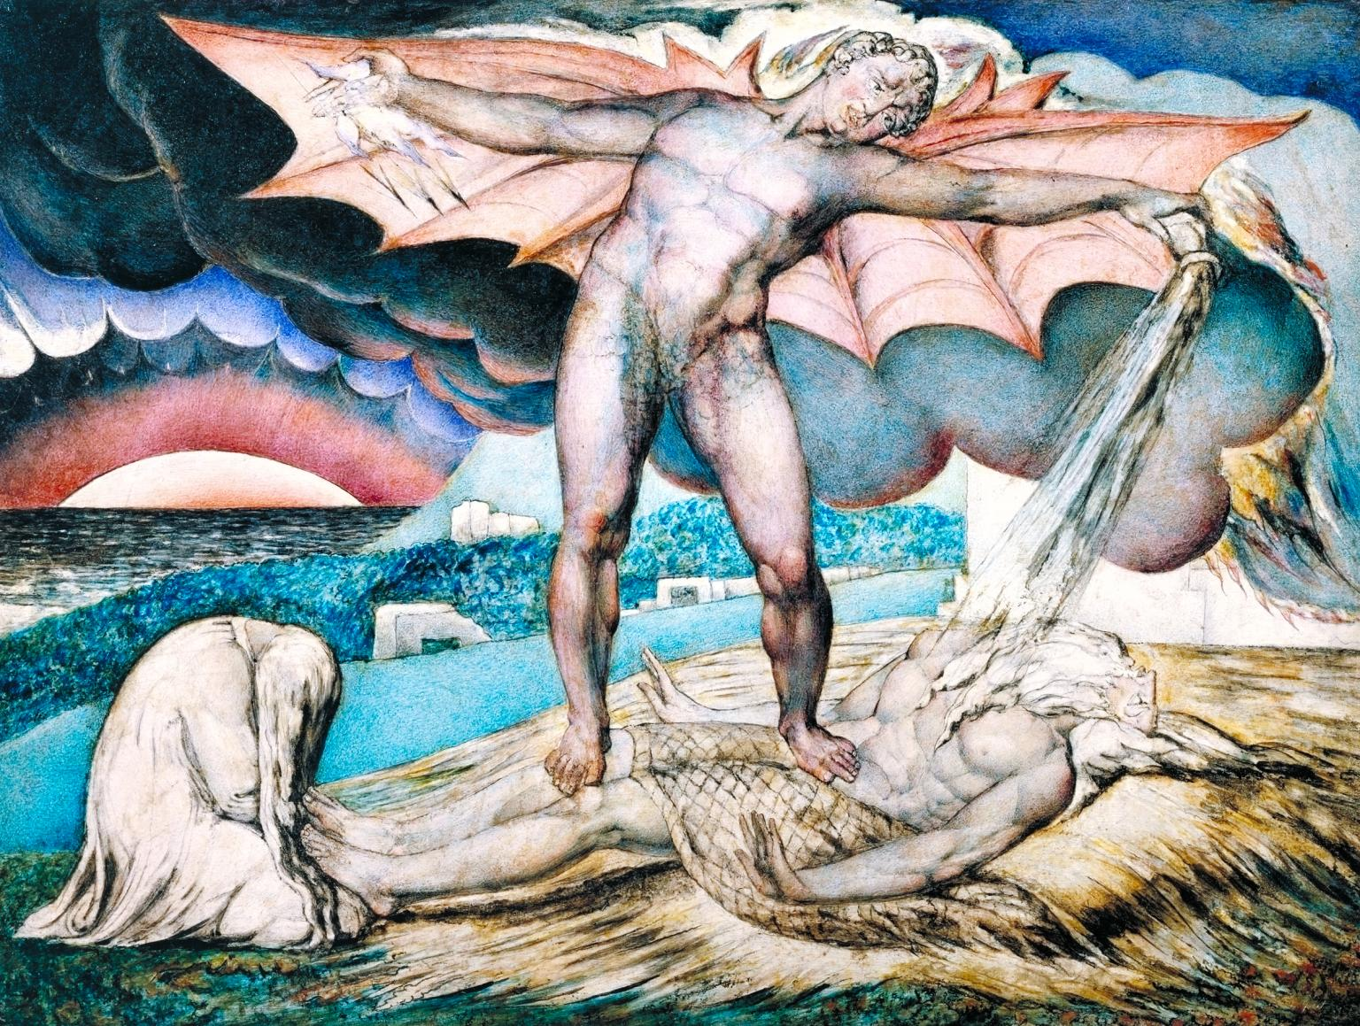
Satan Smiting Job 1826 William Blake

What are we doing in this class?
This class is a general survey of the humanities. The textbook will cover immense time periods from prehistory to the present with a general focus on the Western Canon. We will not read everything in the book and will use the timeline as a way to ground our deeper conversations in historical context with attention to big ideas and moments. In doing this, the class will focus on some of the material with more attention in order to bring focus to a handful of critical ideas we will examine throughout time. Here are a few big questions to consider.

- What is human consciousness and how does a look over the products of different human cultures tell us about this remarkable attribute?
- As we examine artifacts from various cultures in the timeline, what does the artifacts tell us about human interests, both in the context of the history and in a more general, universal way from our position in time?
- As strange and different as other times may appear, what stays the same?
- Because we are dealing with such an extremely vast amount of time, we will need to focus on some of these general questions and bring to our conversation materials from many disciplines to think through what influential lines of thought have been put to these questions over time: Anthropology, psychology, and philosophy to name three of the main disciplines that themselves have contributed to the humanities. We will discuss some of the basic contemporary and formative ideas from all three of these disciplines.

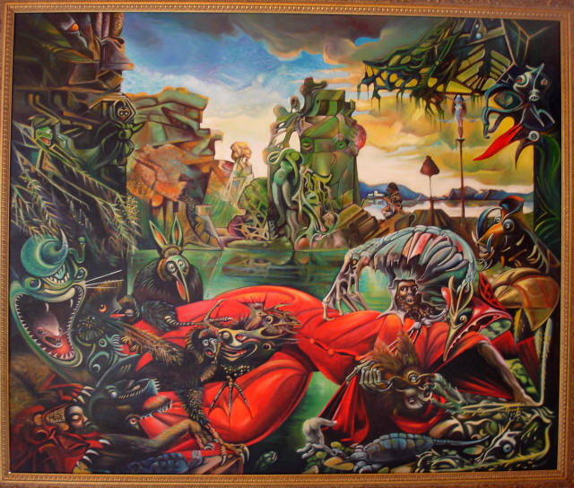
The Temptation of St. Anthony 1945 Max Ernst
Email Rules:
I will not answer an email that does not identify your name, the class (prefix and CRN) and the time and the day, as well, of course, the issue, in the subject as a new email, not as an response to anything I have sent you in the class. You should write your email using full grammatical rules and sign it. I will never answer an email regarding material you missed in class due to absence unless we have arranged it prior or you can prove it was an emergency. I repeat, I will not answer email with no prefix, CRN, name, and subject or with questions about what you missed if you were absent without a prior arrangement or proof of emergency, so if you are wondering why you are not getting answers to your email, I will know you have not looked at the syllabus. If there is a credible reason, make an appointment to come by and ask me in person. I will be more than happy to discuss it with you in that manner.

Always know that if you need to talk to me about anything within the range of the class, that I would be happy to do so. If you are having trouble with an idea, with an approach, or any number of things, I am open to discussing this with you.
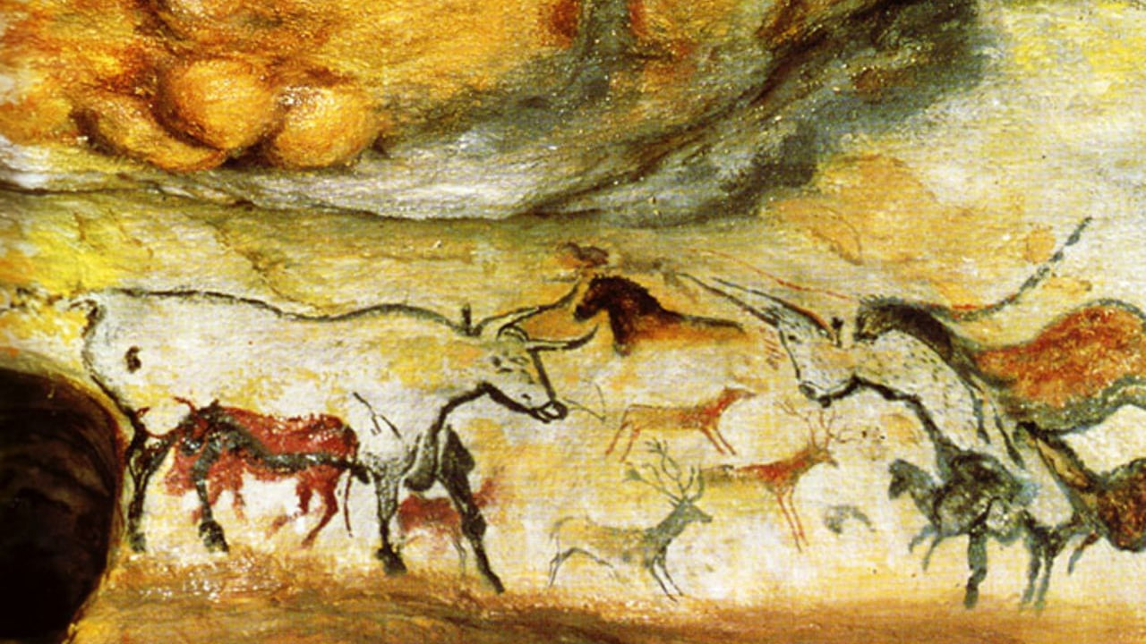
Cave Painting from Lascaux (southwestern France) 20,000 years old

Office Hours:

Professor Warren Office Hours  Bwarren11@valenciacollege.edu ext 1250 Office: 5-248 | Making an appointment is always a better idea, but you are welcome to drop by my office any time I am available.
MW: 11:30-12:30  Tuesday only: 9:00-10:00  TR: 1:30-2:30  F: email 12:00-5:00 | If you need to make a special appointment or need to talk to me for any reason, please feel free to approach me and make arrangements.  If I am here, and you have a question of any kind, please feel free to drop in

Required Texts & Materials:
Landmarks in Humanities Valencia College Edition. Gloria K. Fiero 4th edition
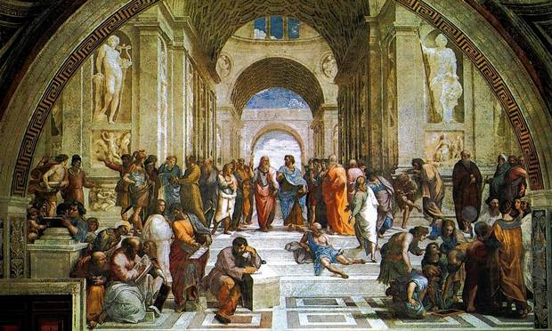
The School of Athens 1509-1511 Raphael
Behavior and other rules:

How you could potentially fail my class or be asked to leave and be counted as absent….make sure you read.
You, the student, are responsible for withdrawing yourself, but I may withdraw you for no show or fail you for the class for other reasons, depending on the situation; being interruptive, annoying, or disrespectful to your peers or your instructor are all valid reasons. Using your phone in class or even passing notes, if it distracts from the class. Overtly racist or bigoted comments about sexual orientation, race, gender, nationality, religion or creed, politics, etc, may, upon my discretion, harm your grade and get you counted as absent for the day. If a situation is bad enough to warrant it, you may end up in front of the dean of students. I encourage critical thinking and academic questioning. Legitimate critical thinking is absolutely not considered rude or disrespectful, but it must be done within an academic framework for the purposes of this class’s academic goals. Mere personal opinion, while important to each of us, is not particularly valuable in academics at this level of analysis, though it may help inspire your critical drive. Keep this in mind …we must all work together in the class discussions, and while I want there to be open honest discussion, I do not want you to forget your manners and your ethics when dealing with other people. This is not Facebook, this is not going to be modelled on culture at large, whatsoever. If you do not reflect on the ethics of your approach to social interaction, now would be as good a time to start. When in doubt, feel free to ask. Keep in mind that use of a cell phone to text during class is absolutely forbidden and counts as disruptive behavior in this class. See technology section for more about tech in the classroom.

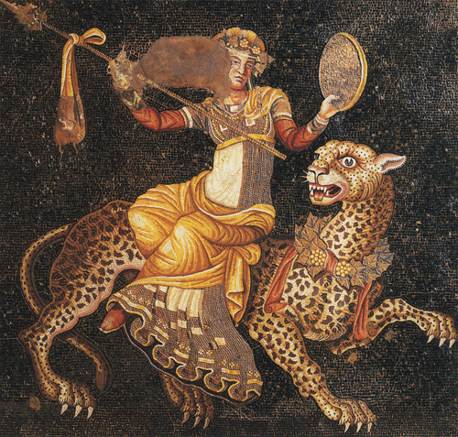
Hellenistic Mosaic of Dionysus Riding a Leopard c. 120-80 BCE

Attendance and Tardiness:

Every student is expected to attend every class. Students arriving late or leaving early will be documented; two late arrival/self-dismissals will result in an absence. Excessive absences mean I will fail the course. I will leave you in the course and you will simply fail; missing a week or more of instruction in a fifteen-week class greatly reduces your chances of being successful. I reserve the right to fail anyone who misses more than a week and turns in only seventy-five percent of their work, rather than drop you from the class, so please keep this in mind. It is your responsibility to show up for a class and know what is happening in a class. If you have challenges at any point in the semester please bring this to my attention so we can work out what is the best alternative for you as a student. If you are proactive about possible problems, that is much better. Waiting until after there is a problem may end up costing you points or worse, depending on the scenario.
La Divina Commedia di Dante 1465 Domenico di Michelino
Other class protocol:

You may lose points, be counted as not present, be asked to leave if you do not keep these rules in mind. What I will do is at my discretion.

This is a face to face class. All things you miss in class are your responsibility. Assignments are announced in class, not on Canvas.

- Please avoid getting up in the middle of class to use the restroom, make/answer a call etc., unless you have a medical condition documented in writing by the OSD. If we watch a documentary, you may not go to the restroom unless it is an emergency, or you may be asked to stay outside, wait till the documentary is over and be counted absent.

- There will be NO general NEED, for you to have an iPod, recorder, phone, or computer (laptop) in class. IF YOU PLAN TO USE A LAPTOP, YOU BETTER ASK FIRST. I make exceptions for anyone that turns in a contractual understanding that is signed and dated about tech usage. This contract should state that you understand that you are to only use tech for the sole purposes of taking notes in class and that you understand that if you are caught doing something else, you automatically may fail the class outright. Write the above understanding on a piece of paper, then sign and date it and turn it into me. The only way this will be altered is if you have paperwork from OSD that requires you to use technology. This contract must be turned in before you use any technology.

- The contract you must type up then date and sign: I (insert name here), understand that I am using technology for the sole purpose of class while in class. This means only for note taking purposes or as directed in class specifically. If I use technology for any other reason, I realize that I could fail the class outright. Date: Signature:

- Please turn off or silence all cell phones BEFORE you get to class. Also, avoid using other smart tech such as smartwatches to text or keep track of texts while we are in class.

- Falling asleep = absence. See above policy. If you fall asleep, you may be asked to leave the class. While this behavior may or may not get you withdrawn, it will result in a reduced grade.

- Students with disabilities/special needs should contact me with OSD forms for appropriate adjustments and/or accommodations in class. This is up to you. If you do not inform me that you have special needs, I officially do not know and do not have to accommodate you. I will try of course, but I need to know what you need to make the class work for you.

- Baycare Behavioral Health’s Student Assistance Program

Include this statement, which is useful to students in need of private counseling:
“Valencia is committed to making sure all our students have a rewarding and successful college experience. To that purpose, Valencia students can get immediate help that may assist them with psychological issues dealing with stress, anxiety, depression, adjustment difficulties, substance abuse, time management as well as relationship problems dealing with school, home or work. Students have 24 hour unlimited access to the Baycare Behavioral Health’s confidential student assistance program phone counseling services by calling (800) 878-5470. Three free confidential face-to-face counseling sessions are also available to students.”

Other important things to keep in mind:

If you miss a class, it is YOUR responsibility to know what you missed and to make up the work. If you miss: I mentioned this earlier, but it cannot help but repeat….DO NOT CONTACT ME THE NEXT DAY AND ASK WHAT YOU MISSED!!!!

Notes and discussion: get highlights from a classmate; please do not count on me to fill you in.
In-class activities: Only students who are PRESENT count.
Turning in an essay/written assignment: These papers must be submitted in person and at the start of class on the day they are due, UNLESS I SAY DIFFERENT. Any assignment turned in after this time will likely lose points. If you know you will miss one of these days, turn it in early in class, or turn it in to the Fine Arts Office, 5-146, to have it time/date stamped and put in the appropriate mailbox…just tell them my name. If these options are impossible, you must get permission FROM ME, BEFORE THE DUE DATE, to send your assignment(s) via Atlas. I do not use blackboard at this time. Do not leave work anywhere else, especially under my office doors.

All late work is subject to losing a letter grade at my discretion (10%) per day, including weekends. I do take into consideration that life is not fair and that things can get in the way, but it better be good. I sometimes have to follow these rules, but in the end I try my best to facilitate your learning.

Plagiarism is unacceptable
All work submitted for credit in this class must be the product of the individual student’s own original thoughts supported and informed by appropriately documented and credited sources. Plagiarism is the use of someone else’s words, ideas, pictures, design, and/or intellectual property without the correct documentation and punctuation.
For this class: This includes using the same information as a friend or fellow student, partner, etc. to answer a critical question in an assignment or looking up material online and using that verbatim, which you should not do. If you find it necessary to look anything up, then you should document where and put your answer in your own words.
If you so plagiarize, you risk automatic failure of the assignment and possibly the class, depending on how serious the problem.

Keep in mind as a final note that we are going to look through the lens of both contemporary and period ideas about the nature of humanity. That means that we may deal with ideas that are not agreeable to your thinking as it is. This is natural and part of the education process. I do not require you to agree or disagree with any of the ideas expressed. I only require that you try to understand the approaches relative to the critical discourse on the topics at hand. I require that you understand the basic attributes of the timeline and materials we cover through an academic lens. While everyone’s beliefs and traditions are important and part of their lives, please keep in mind that this is an academic class with academic aims.
Important Dates:
Keep in mind that you must stay aware of the important dates throughout the semester, like the date by which you must apply to graduate, which is September 14th. You will find the dates in total here:
https://valenciacollege.edu/academics/calendar/documents/important-dates-calendar-2019-2020.pdf
Academic Calendar:
If you need to know if we are meeting, there is holiday and other basic dates, click here:
https://valenciacollege.edu/academics/calendar/

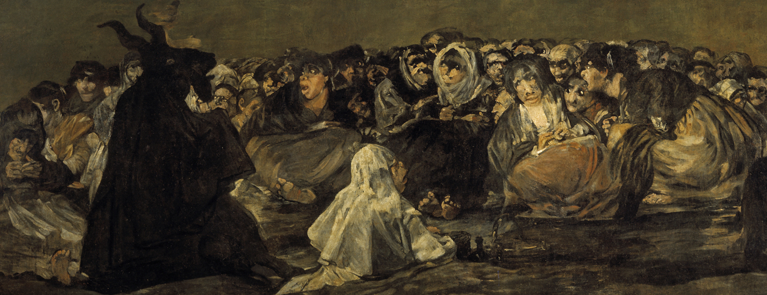
Witches Sabbath 1819-1823 Francisco Goya

